**Virtualization:**

Virtualization creates a virtual version of underlying services, enabling multiple operating systems and applications to run simultaneously on the same hardware, improving utilization and flexibility.

**Desktop Virtualization:**

* **Desktop Virtualization** is a technology that allows a user's desktop environment, including the operating system, applications, and data, to be hosted on a remote server rather than on a local machine.
* Users can access their virtual desktop from any device with an internet connection, providing flexibility and mobility.

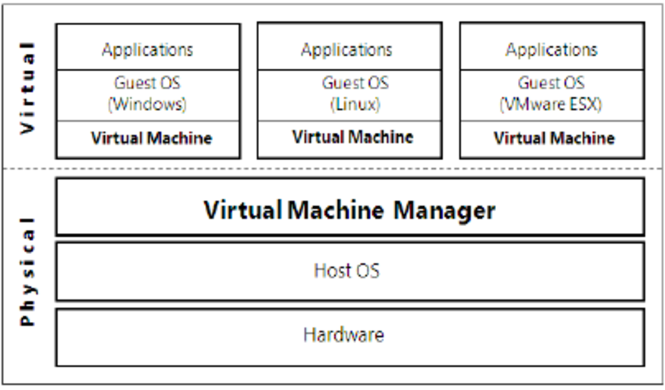

**Key Features of Desktop Virtualization:**

* **Remote Access**:  
  Users can access their desktop from any location, using different devices, such as laptops, tablets, or smartphones.
* **Centralized Management**:  
  IT administrators can manage, update, and secure the desktop environments centrally, improving efficiency and reducing overhead.
* **Support for Multiple Operating Systems**:  
  Desktop virtualization allows users to run different operating systems (such as Windows, Linux) on the same device.
* **Cost Efficiency**:  
  It reduces hardware costs, as the desktops can be run on virtual machines on servers instead of requiring high-end machines for each user.
* **Security**:  
  Since data and applications are stored on central servers rather than on user devices, it enhances security and data protection.
* **Scalability**:  
  Virtual desktops can be quickly scaled up or down based on organizational needs, providing flexibility for fluctuating workloads

**Types of Desktop Virtualization:**

* **Virtual Desktop Infrastructure (VDI)**:  
  Desktops are hosted on virtual machines in a data center or cloud, with users connecting via a client device.
* **Desktop-as-a-Service (DaaS)**:  
  A cloud service where the entire desktop environment is hosted and managed by a third-party provider.

Advantage :

* **Enhanced Mobility and Flexibility**:  
  Users can access their virtual desktop from any device, anywhere, supporting remote work and BYOD policies.
* **Centralized Management**:  
  IT administrators can centrally manage, update, and secure virtual desktops, simplifying maintenance tasks.
* **Cost Efficiency**:  
  Virtual desktops reduce the need for expensive hardware, allowing organizations to use cheaper thin clients or repurpose older devices.
* **Security**:  
  Data is stored centrally, enhancing security and enabling robust measures like encryption and multi-factor authentication.
* **Scalability**:  
  Virtual desktops can be quickly scaled up or down based on demand, without the need for new physical hardware.

Disadvantage:

* **High Initial Setup Costs**:  
  Implementing virtual desktop infrastructure (VDI) requires significant upfront investments in servers, storage, and software.
* **Network Dependency**:  
  Virtual desktops rely on a stable, high-speed internet connection; network issues can degrade performance and user experience.
* **Complexity in Large Deployments**:  
  As the number of virtual desktops increases, managing resource allocation and ensuring performance becomes more complex.